Test Case: tc001_SPX_Dev5_Crear_Requisicion_Spot_Tipo_Cobro_CC
Step 1 - Enter username and password and click to button Enter : Credentials Entered
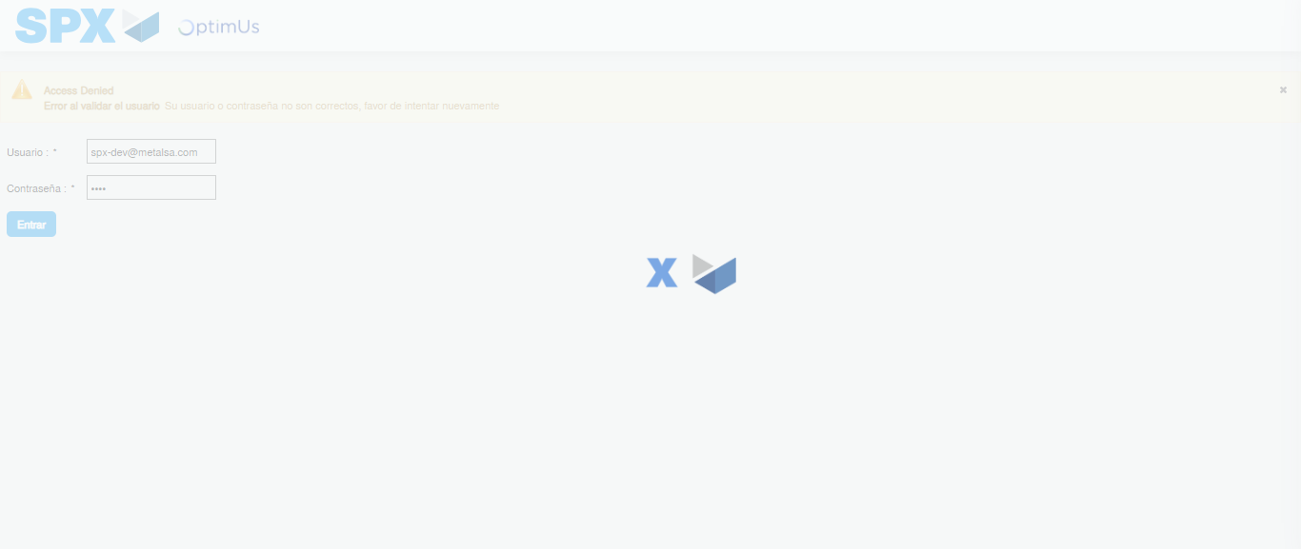Image file-name: QC_Testing-tc001_SPX_Dev5_Crear_Requisicion_Spot_Tipo_Cobro_CC-1783983642365

Step 2 - Select to UEN and Access to Spot Buy Requisitions : UEN Correctly selected and Correct access
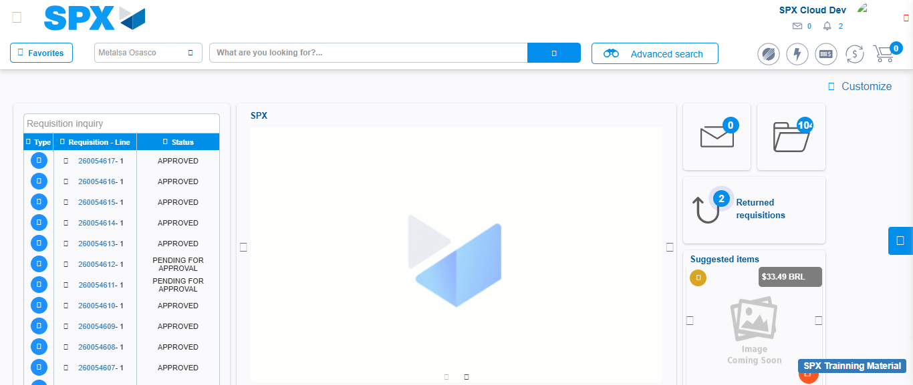Image file-name: QC_Testing-tc001_SPX_Dev5_Crear_Requisicion_Spot_Tipo_Cobro_CC-1783983677766

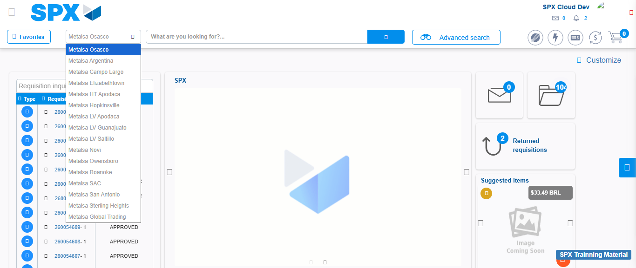Image file-name: QC_Testing-tc001_SPX_Dev5_Crear_Requisicion_Spot_Tipo_Cobro_CC-1783983680335

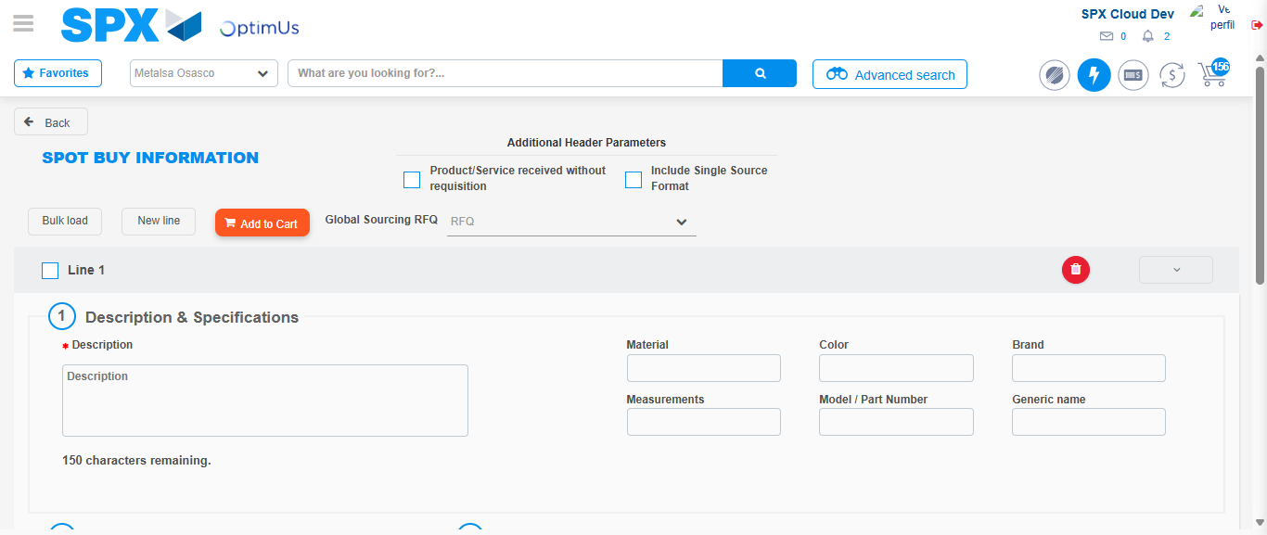Image file-name: QC_Testing-tc001_SPX_Dev5_Crear_Requisicion_Spot_Tipo_Cobro_CC-1783983690040

Step 3 - Data Capture Spot Buy Requisition : Data captured correctly
Image file-name: QC_Testing-tc001_SPX_Dev5_Crear_Requisicion_Spot_Tipo_Cobro_CC-1783983690280

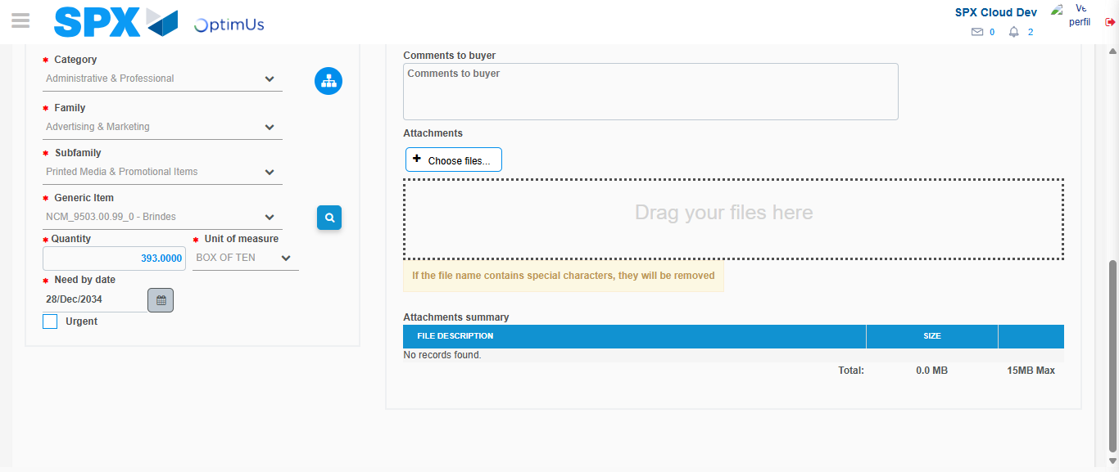Image file-name: QC_Testing-tc001_SPX_Dev5_Crear_Requisicion_Spot_Tipo_Cobro_CC-1783983702475

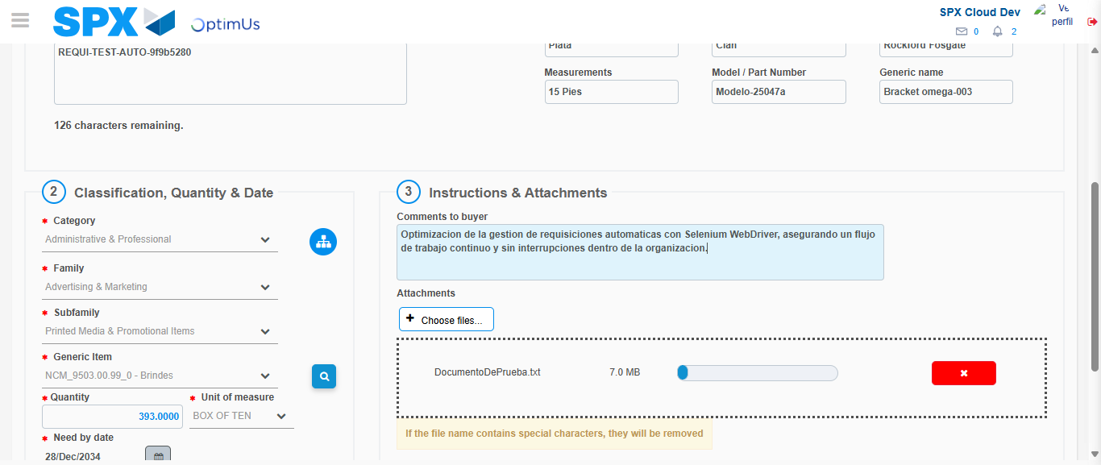Image file-name: QC_Testing-tc001_SPX_Dev5_Crear_Requisicion_Spot_Tipo_Cobro_CC-1783983703240

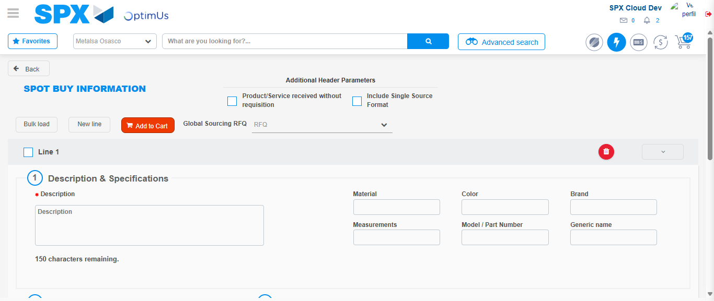Image file-name: QC_Testing-tc001_SPX_Dev5_Crear_Requisicion_Spot_Tipo_Cobro_CC-1783983715757

Step 7 - Return to Main Page SPX : Return to Main Page SPX
Image file-name: QC_Testing-tc001_SPX_Dev5_Crear_Requisicion_Spot_Tipo_Cobro_CC-1783983677766

Image file-name: QC_Testing-tc001_SPX_Dev5_Crear_Requisicion_Spot_Tipo_Cobro_CC-1783983680335

Image file-name: QC_Testing-tc001_SPX_Dev5_Crear_Requisicion_Spot_Tipo_Cobro_CC-1783983690040

Image file-name: QC_Testing-tc001_SPX_Dev5_Crear_Requisicion_Spot_Tipo_Cobro_CC-1783983717951

Image file-name: QC_Testing-tc001_SPX_Dev5_Crear_Requisicion_Spot_Tipo_Cobro_CC-1783983718115

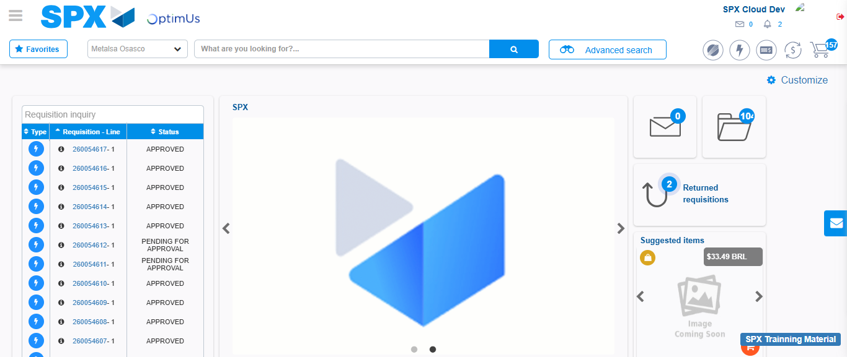Image file-name: QC_Testing-tc001_SPX_Dev5_Crear_Requisicion_Spot_Tipo_Cobro_CC-1783983739177

Step 8 - Log Out : Log Out SPX
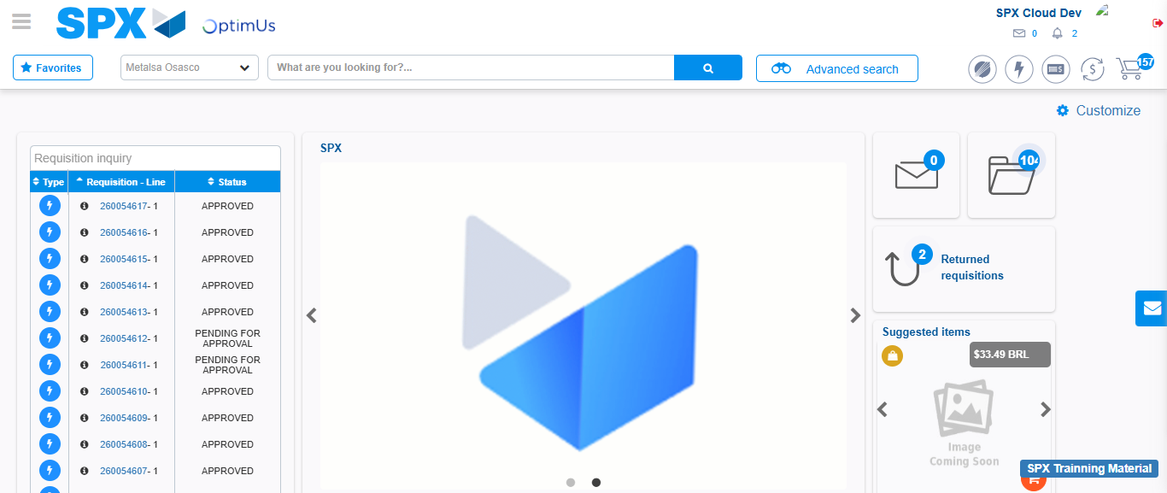Image file-name: QC_Testing-tc001_SPX_Dev5_Crear_Requisicion_Spot_Tipo_Cobro_CC-1783983739468

